CSCI5561 du000078@umn.edu Haoyuan Du 5500151

HW1 Write up

The HOG result:

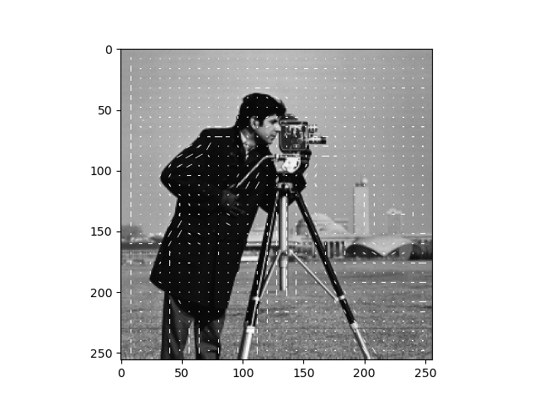男子的脸部特写与配字黑白照

We can see the lines follow the gradient of his shoulders, camera and legs. Also, lines follow the gradient of Obama’s face.

游戏机里面的人物

After implementing the face_recognition and applying thresholding (0.48), we get the image with many bounding boxes.After iou, we get the final result.